MDS3 Use Case - ESG Monitoring

Table of Contents
Introduction 2
Description/Scenario 3
Globus Toolkit Components 4
Index Service 4
Web Service Data Browser 4
Archive Service 4
Trigger Service 4
Test scripts 5
Trigger scripts 5
Framework Architecture (high level) 6
Main Path 7
Required Software 7
ESG Implementation 7
Intended Future Implementation 8
Framework Architecture (low level) 9
Postconditions 10
ESG Visualizer 10
Details Visualizer 11
Archiver Visualizer 11
Resources 12

Introduction
This use case describes an actual scenario where an end user (ESG) implements the Information Services tools of the Globus Toolkit (also known as MDS3) to set up web-based Visualizers that provide resource information about specific servers quickly and easily.

Description/Scenario

The Earth System Grid (ESG) project is building a ‘cyber infrastructure’ of distributed federations of supercomputers and large-scale data & analysis servers to process terabytes of data about the earth’s climate.

The ESG infrastructure includes:

- a Metadata Catalog based on the OGSA Database Access and Integration (OGSA-DAI) Service and stores descriptive attributes about ESG data sets, allowing discovery of data based on particular climate model parameters.
- the Replica Location Service (RLS), a distributed registry that maintains information about multiple replicas of physical files.

Together, the OGSA-DAI and RLS servers allow ESG users to find physical files based on descriptive metadata attributes.
ESG needed an effective way to quickly find information about these services (as well as their web portal at http://www.earthsystemgrid.org) within a monitoring framework that can provide:
- existing monitoring done on an ad-hoc basis.
- a uniform interface to monitor both Globus Toolkit (GT) and non-GT services.
- the ability to monitor services at the site-level and VO-level.
- a web interface to view current status, query previous status.
The Center for Grid Technologies (CGT) of ISI/USC saw this as an opportunity to deploy new and existing components of the MDS technology of the Globus Toolkit in a real-world setting.

Globus Toolkit Components
This section describes the various GT components used to set up the ESG framework:
- Index Service
- Web Service Data Browser
- Archive Service
- Trigger Service
- Test scripts
- Trigger scripts

Index Service
The Index Service is part of the Monitoring and Discovery System (MDS3) of the Globus Toolkit. In essence, it provides a single service that gets information about other services. More specifically, the GT3 Index Service collects service data from various resources and publishes them as one big piece of service data. Other services can query for service data elements or subscribe to be notified when they change.
In the ESG monitoring framework, the GT3 Index Service collects information from testing services and publishes the aggregate information.

Web Service Data Browser
The Web Service Data Browser (WebSDB) is a GUI that displays service data exposed by grid services. The data can be transformed via different Visualizers for better analysis.
In the ESG monitoring framework, the WebSDB is used to query the Index Service and display the current status of ESG services.
Archived data and statistics generated from the archived data can also be displayed by querying the Archive Service (see below.)

Archive Service
The Archive Service (currently being tested) is a new service designed to record Service Data originating from the Index Service, or any other service, and allows time-based queries on historical data. It is similar in functionality to the Index Service, except that where the Index Service keeps only the latest results from each provider, the Archive Service stores every result and time-stamps each one.

Trigger Service
The Trigger Service provides functionality such as an email gateway to notify system administrators when services fail.
The Trigger Service is configured with a set of conditions and actions to be performed.
First, it subscribes to the Index Service. Upon receiving a notification, the Trigger Service then:
- checks each of the conditions with the service data in the notification.
- if any of the conditions are met, it performs the corresponding action.

Test scripts
Test scripts can be simple shell scripts or wrappers around grid service clients. You can use test scripts to potentially test anything that can be tested (such as the OGSA-DAI, RLS servers and web portals tested in this framework.)
In general, these scripts test the service and wrap the results into XML as per a user-defined schema. When the Index Service runs these tests, it publishes the XML returned by these tests as service data.

Trigger scripts
Trigger scripts can be simple shell scripts or wrappers around other applications such as grid service clients, mail clients, etc.
When the trigger service gets a notification from the index service:
- It matches each of the XPath conditions (supplied via a configuration file) against the service data.
- If there are any matches, the action specified (again via the configuration file) is performed.
There can also be an intermediate step where the matching XML is transformed via an XSLT stylesheet supplied via the configuration file.
- Performing the action involves running the specified script with arguments generated from the XSLT transformation.

Framework Architecture (high level)
The following graphic shows a high-level overview of the architecture for the ESG framework:
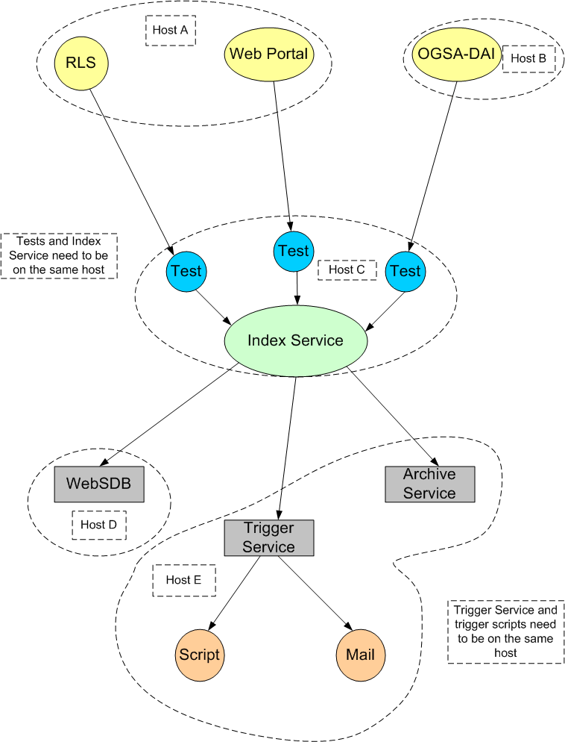

Main Path
The following is a high-level overview of how CGT set up the ESG framework to monitor a new service:
- Set up an Index Service and configure it to publish data from these tests.
http://www-unix.globus.org/toolkit/docs/3.2/installation/install_config_index.html
- Set up hierarchy (index services aggregating other index services)
- Set up Archive Service and subscribe to the correct Index Service.
[link to future directions]
- Configure the Trigger Service with conditions and action scripts for this service.
- Write Visualizers (ESG, Archive, Details, explained below), using XSL stylesheets for formatting and displaying the data.
- Set up WebSDB and install Visualizers.
http://www-unix.globus.org/toolkit/docs/3.2/infosvcs/ws/developer/sbrowser.html

Required Software
- Globus Toolkit 3.2
http://www-unix.globus.org/toolkit/downloads/
- the Archive Service package
(coming soon)
- Trigger service
(coming soon)
- the Web Service Data Browser
(in the GTR)

ESG Implementation
The following details are specific to deploying the monitoring framework for ESG:
- All components are installed on dc-user.isi.edu (CGT machines) using a single index service.
- Status of services is available on this web page:
http://snipurl.com/StatusPage [shishir needs to provide nicer URL]
- The Trigger Service sends an email when a broken service is detected.
- The following data is captured:
  - Status (whether the server is up or down)
  - Percentage of uptime
  - Time when the service was last seen alive
  - Time when the service failed

Intended Future Implementation
- Displaying archived data in more interesting and meaningful ways
- Deploying on an ESG node

Framework Architecture (low level)
The following graphic illustrates in more detail how the ESG framework was implemented:
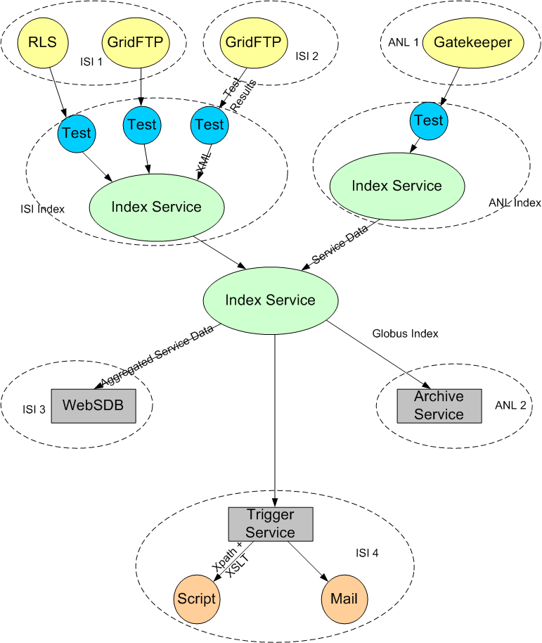

Postconditions
As a result of this deployment, ESG now has the following:
- A scalable system that can easily cope with services being added and removed.
- Better integration with the rest of the Globus Toolkit.
- Status available for other services to query via the Index Service
- Test results returned as XML:
  - In our current test schema, we allow for a binary UP|DOWN status value, and also a free form comment
  - the free form comment can contain, for example, RLS stats which include number of mappings in the LRC/RLI, uptime, etc.
  - Complex XPath queries can be run against these results as part of the triggering mechanism
- Web-based visualizers that display the status of its chosen services (see the following topics.)

ESG Visualizer
This is the ‘entry page’ for checking out how the various services are doing: status (whether the service is UP or DOWN) and links to more information from the Archiver and Details visualizers. View the ESG Visualizer here.
Screenshot of the ESG Visualizer:
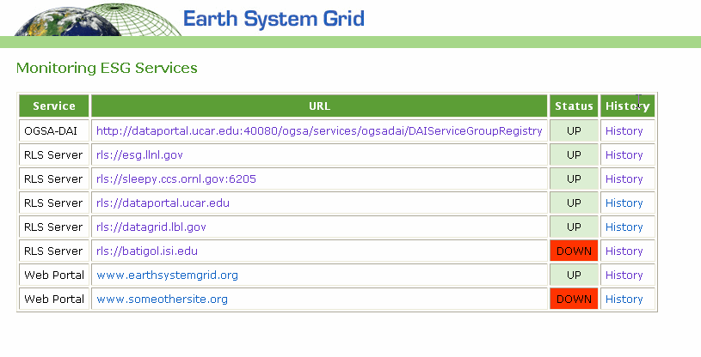

Details Visualizer
From the ESG Visualizer, the Service URL link takes you to the Details Visualizer.
Example of the Details Visualizer:

rls://esg.llnl.gov
Version: 2.0.9
Uptime: 1588:38:54
LRC stats
update method: lfnlist
update method: bloomfilter
updates bloomfilter: rls://datagrid.lbl.gov:39281 last 05/13/04 15:23:59
lfnlist update interval: 86400
bloomfilter update interval: 900
numlfn: 549
numpfn: 551
nummap: 551
RLI stats
updated by: rls://esg.llnl.gov:39281 last 05/13/04 13:39:00
updated by: rls://datagrid.lbl.gov:39281 last 05/13/04 13:40:11
updated by: rls://sleepy.ccs.ornl.gov:6205 last 05/13/04 15:25:50
updated by: rls://dataportal.ucar.edu:39281 last 05/13/04 14:18:43
updated via bloomfilters

Archiver Visualizer
From the ESG Visualizer, the History link takes you to the Archive Visualizer, which displays the historical data ESG specified (percentage of uptime, the timestamp of the reading, status of the server, reporter (test script) and URL.)
Screenshot of the Archive Visualizer:
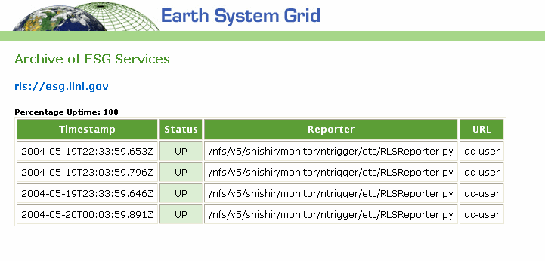

Resources
This page provides information about where and how you can access the tools used in this implementation:
Index Service | The Index Service is currently available as part of GT3.2:  http://www-unix.globus.org/toolkit/downloads/3.2/index.html  Install the All Services or WS Base Installer package.
Web Service Data Browser | Developed by Arslan Javed ajaved@isi.edu  Available from the Grid Technology Repository: http://gtr.globus.org/article.php?story=20030723143444410
Archive Service | Developed by June Sup Lee (june@isi.edu)  Currently only available through the Globus CVS.
Trigger Service | Developed by Shishir Bharathi (shishir@isi.edu)  Currently available [where?]

